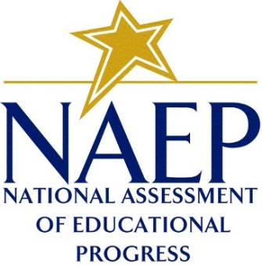
Temporary Job Opportunities: Assessment Administrators
We are seeking motivated individuals who are committed to excellence and have experience working in schools with students. Westat is recruiting for the 2019 National Assessment of Educational Progress, also known as NAEP or The Nation’s Report Card, for the National Center for Education Statistics, which is part of the U.S. Department of Education.

The position involves conducting assessment sessions with 4th-, 8th-, and 12th grade students using touch-enabled tablets in participating schools across the country. You will work on a team of 2-4 people. This opportunity is ideal for retired educators.

Your duties will include:
- Administer assessment sessions using tablets in schools;
- Prepare the room and set up equipment;
- Check student attendance and read directions aloud to students;
- Monitor the assessment sessions using NAEP tablet;
- Answer student questions using prepared guidelines;
- Collect assessment materials when the assessment is complete;
- Ensure quality control is achieved; and
- Assist in packing assessment equipment.

Westat provides complete paid training, paid time and mileage reimbursement for local driving to and from schools, weekly paychecks with direct deposit, and opportunities for advancement based on performance.

Qualified applicants must:
- Be available to work 20 to 30 hours a week, during daytime hours, when work is available, from January 28 to March 8, 2019; and
- Complete required components of training, including an online course to be completed independently, and a two-day in-person meeting during January 2019.
- Be willing to complete background check requirements, including an FBI fingerprint check;
- Have access to telephone service with a long distance calling feature;
- Have access to computer, broadband Internet connection, and personal, private email account;
- Have a valid (current) driver’s license that is not under suspension and regular access to an insured, reliable vehicle to travel to and from schools; and
- Have a high school diploma or GED.
The following criteria are preferred:
- Prior experience working in an educational setting or working with students;
- Prior experience working in a team environment;
- Excellent verbal and written communication skills;
- Strong interpersonal skills;
- Basic computer proficiency;
- Self-motivated, organized, flexible, and detail-oriented;
- Willingness to travel overnight, if necessary; and
- Be willing and able to lift and carry up to 50 pounds (which included technical equipment) and be able to climb stairs if needed with or without reasonable accommodations.

This opportunity is a part-time, temporary position with limited benefits. For more information, visit www.workNAEP.com and provide your name and email. We will contact you with a link to our online application when it is available. Online applications will be accepted beginning in June 2018.

For more information email NAEPrecruit@westat.com
WESTAT
EOE

